GOVERNMENT OF INDIA
Ministry of Commerce & Industry | National Industrial Corridor Development Corporation (NICDC)
Industrial Corridor Project Management System (IC-PMS) | Version 1.0

SECTION 5
Integration Architecture
Detailed Technical Documentation
Inter-Module Integration · Government of India Digital Systems · Satellite & Geospatial · API Security · Event-Driven Architecture · Primavera P6/Unifier

Document Version: 1.0 | March 2026 | Classification: Restricted – Government Use Only
IC-PMS Solution Architecture Team | NICDC | Ministry of Commerce & Industry, Government of India

5.1 Integration Architecture Overview
IC-PMS is not a standalone project management system — it is the digital governance layer that connects India's industrial corridor programme management with the wider ecosystem of Government of India digital infrastructure, statutory regulatory portals, geospatial intelligence platforms, labour compliance systems, and enterprise project management tools. Section 5 defines how IC-PMS integrates with each of these external and internal systems, the data flows, the API protocols, the security architecture, and the integration patterns that govern each connection.
The integration architecture is designed around five core principles: (1) All government digital systems are integrated via standard, NeSDA-compliant REST/JSON APIs; (2) Event-driven integration via Apache Kafka eliminates tight coupling between modules and enables real-time cross-module data flows; (3) The API Gateway (Kong) enforces OAuth 2.0 / JWT authentication, rate limiting, and audit logging for every integration endpoint; (4) No personal data or classified project data leaves NIC MeghRaj sovereign cloud; and (5) Every integration has a manual fallback to prevent a third-party system outage from blocking IC-PMS operations.

5.1.1 Integration Architecture Layers
Layer | Components | Purpose
Client Layer | React.js Web, React Native Mobile PWA, Primavera P6 XER Sync, Lender REST API Client | User-facing interfaces and external system connectors that initiate API calls
Perimeter Security | WAF (Web Application Firewall), DDoS mitigation, TLS 1.3 enforced, IP whitelisting for GoI systems | First line of defence — blocks malicious traffic before reaching the application
API Gateway | Kong API Gateway — rate limiting, OAuth 2.0/JWT validation, versioning (v1/v2), request logging, circuit breaker | Central control point for all inbound and outbound API traffic
Authentication Layer | NIC LDAP/SSO, Aadhaar OTP (UIDAI), USB DSC Class 3, SAML 2.0, RBAC Policy Engine | Identity management and access control for all users and system-to-system connections
Event Bus | Apache Kafka — satellite ingestion stream, module trigger events, payment confirmations, audit log | Asynchronous event-driven communication between IC-PMS modules and external systems
Microservices | Module REST APIs (M1–M9), GraphQL Federation for dashboard queries, Redis Cache, Service Mesh (Istio) | Independent module services communicating via events and APIs
Data Layer | PostgreSQL 15 + PostGIS, Elasticsearch, InfluxDB (time-series), NIC DigiLocker, MinIO (object storage) | Persistent storage with AES-256 encryption at rest

5.1.2 Overall Integration Map
The following diagram shows IC-PMS as the hub of a spoke-and-hub integration architecture, with nine external ecosystem clusters connected via the API Gateway: Government of India financial systems (PFMS, GeM, CPPP), NIC infrastructure services (DigiLocker, e-Office, SSO, SMS Sevak), satellite and geospatial systems (ISRO Bhuvan, Planet Labs, Survey of India), regulatory portals (PARIVESH, DLRMS), labour compliance systems (EPFO, e-Shram), enterprise PM tools (Primavera P6, Unifier), and external reporting recipients (lenders, CAG, Ministry).
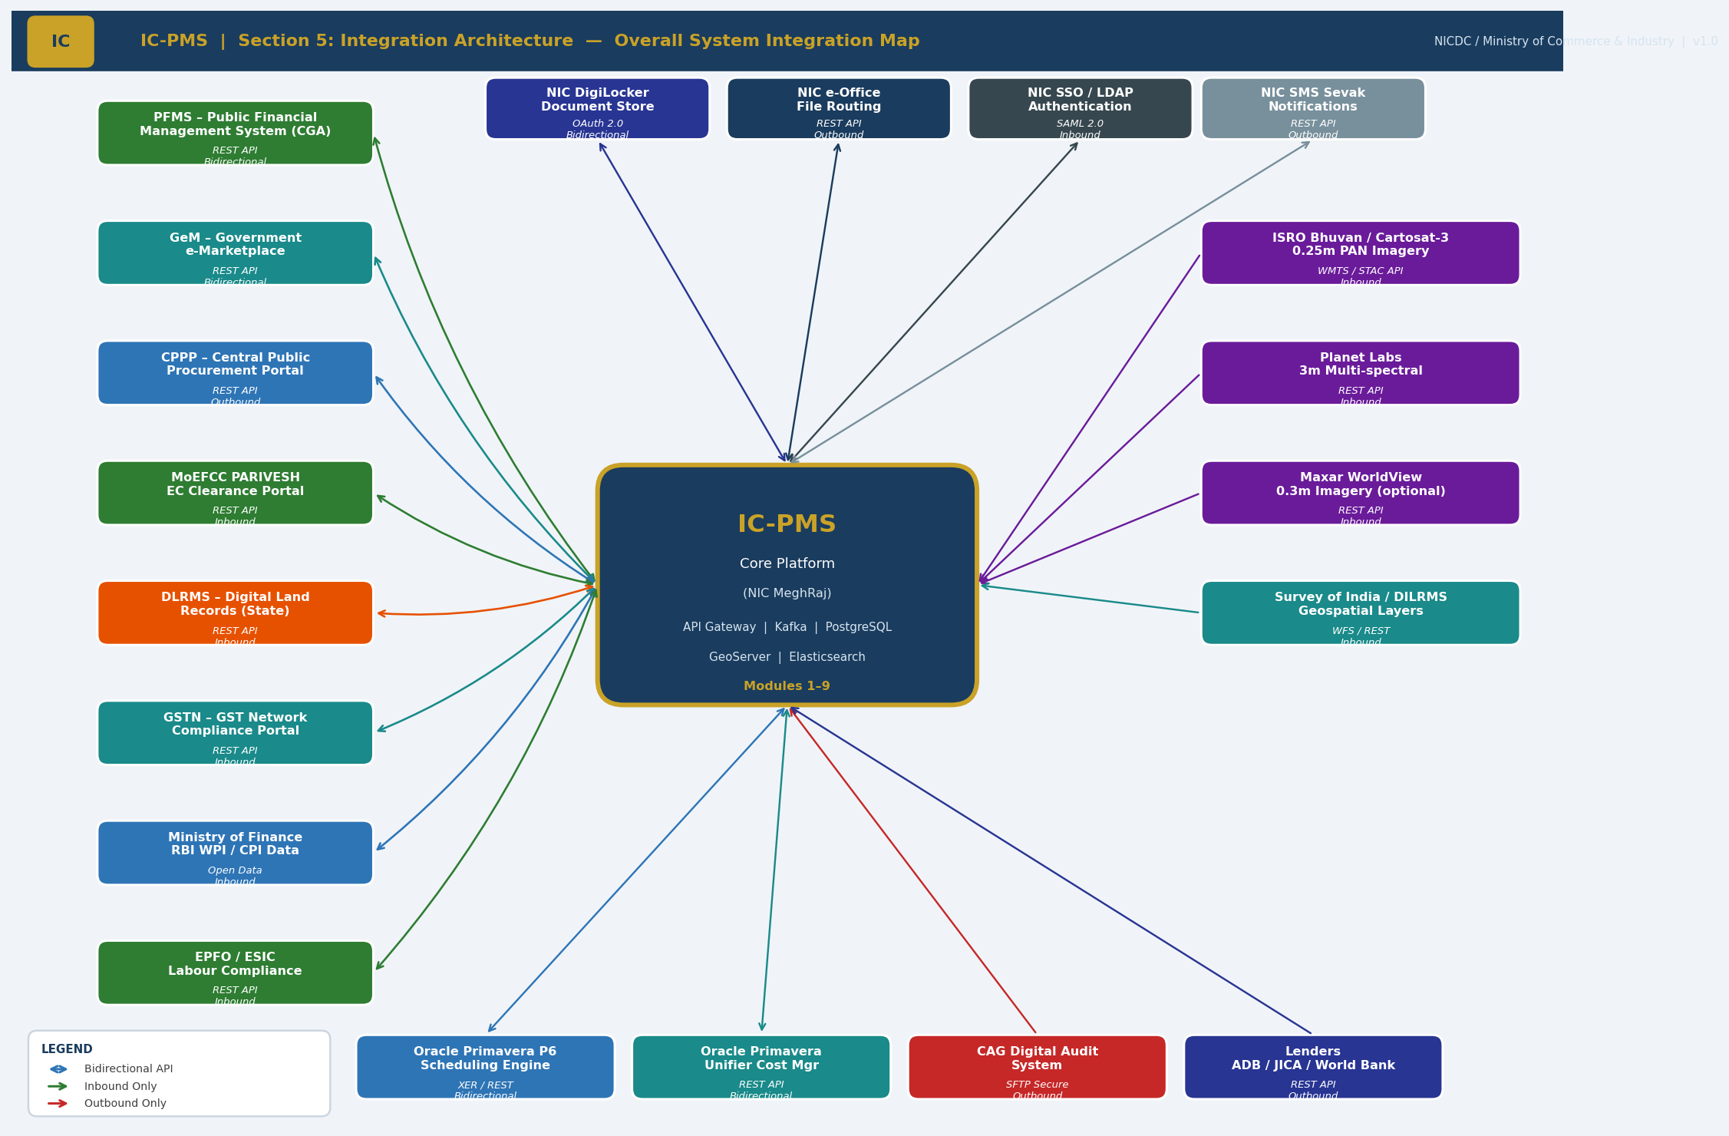
Figure 5.1 — IC-PMS Overall Integration Architecture Map (Hub-and-Spoke, 9 External Clusters)

5.2 Inter-Module Integration — Internal Data Flows
Within IC-PMS, the nine modules are not siloed — they are deeply interconnected through both synchronous REST API calls (for real-time data lookups) and asynchronous Kafka events (for trigger-based cross-module updates). Module 9 (Reporting & Analytics) aggregates data from all other modules through the Data Warehouse ETL pipeline. The inter-module integration matrix below shows every data flow between modules.

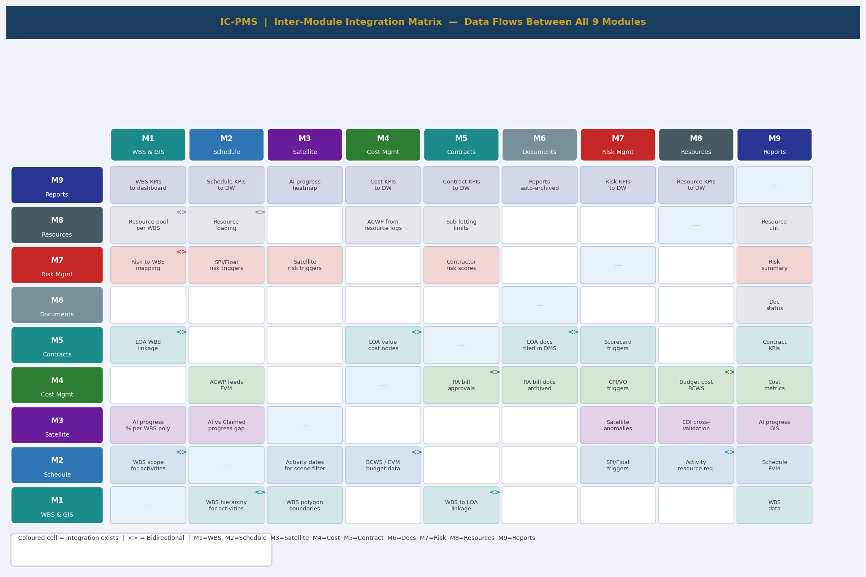
Figure 5.2 — Inter-Module Integration Matrix (Coloured Cells = Integration Exists; <> = Bidirectional)

5.2.1 Critical Cross-Module Data Flows
MODULE 1 — ALL MODULES | WBS as the Universal Reference

Module 1 (WBS & GIS) is the master reference structure for every other module. Every activity in Module 2, every cost node in Module 4, every contract in Module 5, every document in Module 6, every risk in Module 7, and every resource in Module 8 is linked to a WBS element. This linkage ensures that all programme data can be aggregated and reported at any WBS level — from individual work package to full corridor portfolio — without manual reconciliation.
From M1 | To Module | Data Flow | Trigger / Frequency
WBS hierarchy (Programme → Work Package) | Module 2 | Activity list scoped to WBS; activities cannot be created without a valid WBS parent | On WBS publish; on WBS structure change
OBS (Organisational Breakdown Structure) | Module 5 | Contractor-to-WBS mapping drives LOA assignment and performance scorecard scope | On OBS update; real-time API lookup
GIS polygon boundaries (PostGIS WKT) | Module 3 | Defines the geographic boundary for each WBS element; Module 3 AI computes progress within these boundaries | On polygon upload; weekly satellite processing
WBS cost account codes (PFMS head) | Module 4 | Budget nodes aligned to PFMS Demand Nos.; ensures budget-to-WBS linkage for PFMS payments | On WBS publish; on cost account update
WBS risk linkage | Module 7 | Risks must be linked to a WBS element; risk score shown in WBS tree view | Real-time on risk creation/update
Resource pool per WBS | Module 8 | Resource planning at WBS package level; levelling respects WBS hierarchy for prioritisation | Daily ETL to Data Warehouse

MODULE 2 (SCHEDULE) ↔ MODULE 4 (COST) | EVM Integration

The Earned Value Management (EVM) calculations in IC-PMS depend on a tight, real-time link between Module 2 (Schedule) and Module 4 (Cost). Module 2 computes BCWP (Earned Value) from the physical % complete of activities; Module 4 provides the ACWP (Actual Cost) from RA bill payments and resource logs. The resulting SPI and CPI values are the primary performance indicators across the entire IC-PMS system.
Data Flow | Direction | Detail | Update Frequency
BCWS (Budgeted Cost of Work Scheduled) | M4 → M2 | Resource-loaded baseline cost per activity, time-phased by duration | On baseline set; on resource assignment change
BCWP (Budgeted Cost of Work Performed) | M2 → M4 | Calculated as: BAC × Physical % Complete (from PMC entry or AI %) | On % complete update; daily at data advance
ACWP (Actual Cost of Work Performed) | M4 → M2 | Cumulative RA bills paid + resource logs from Module 8 | On RA bill approval; on resource log entry
EVM Metrics (SPI, CPI, EAC, CV, SV) | M2 (computed) | All EVM metrics computed by Module 2 scheduling engine using BCWS, BCWP, ACWP | Daily at data date advance; on-demand
Resource cost from M8 → M4 ACWP | M8 → M4 → M2 | Labour/equipment actual costs exported as ACWP component | Daily labour log entry; equipment log entry
EAC forecast → Module 9 DW | M2+M4 → M9 | P50/P80 EAC from Monte Carlo (M7) + Deterministic EAC published to Data Warehouse | Monthly on MC refresh; daily deterministic

MODULE 2 + MODULE 3 → MODULE 7 | Automatic Risk Triggers

One of IC-PMS's most distinctive integration features is the automatic generation of risk triggers from operational performance data in Modules 2, 3, 4, and 5. This eliminates the dependence on manual reporting of bad news — when a key performance threshold is breached, Module 7 is informed automatically.
Source Module | Trigger Condition | Module 7 Action | Alert Level
Module 2 — Schedule | Activity SPI < 0.85 for 2+ consecutive data dates | Upgrade schedule risk for that WBS package by one severity level; notify PMC | P3 Warning → P2 Urgent if SPI < 0.80
Module 2 — Schedule | Critical path Total Float = 0 days on activity not yet complete | Create or update schedule risk linked to that CP activity; flag 'No Float Remaining' | P2 Urgent
Module 3 — Satellite | Encroachment alert detected (construction outside DPR boundary GIS polygon) | Create regulatory/compliance risk record; escalate to NICDC Legal | P2 Urgent — same day
Module 3 — Satellite | Idle zone detected in active WBS area for 14+ consecutive days | Upgrade contractor risk for that package; trigger Module 5 performance notice | P3 Warning
Module 3 — Satellite | NDVI vegetation loss exceeding Environmental Clearance limit | Create environmental risk; notify NICDC Environment Cell; MoEFCC notification flagged | P2 Urgent
Module 4 — Cost | Package CPI < 0.85 for 2+ data dates | Create cost risk for that package; auto-compute contingency drawdown recommendation | P3 Warning
Module 4 — Cost | Cumulative VO value > 8% of LOA (approaching GFR 10% ceiling) | Create scope creep risk; notify PMC and SPV PM; trigger VO justification review | P3 Warning → P2 at 9%
Module 5 — Contract | Contractor performance scorecard < 60 for 2 consecutive months | Upgrade contractor default risk; notify NICDC Programme Director | P2 Urgent

MODULE 4 (COST) ↔ MODULE 5 (CONTRACTS) | Payment and Procurement Integration

Data Flow | Direction | Detail
LOA value and terms → Budget constraint | M5 → M4 | On LOA award, contract value locked in M4 as the upper budget ceiling for that WBS package; VO approvals update this ceiling
RA Bill → Payment pipeline | M4 → M5 (reference) | Each RA bill in M4 linked to LOA in M5; payment history visible in contract view
Retention, mobilisation advance, LD deductions | M5 → M4 | Deduction rates defined in contract terms (Module 5) auto-applied in Module 4 bill processing
GeM purchase orders → Material cost | M5 (GeM) → M4 | Material delivery confirmed via GeM API → Module 5 → Module 4 material cost posting
BG / PBG expiry alerts | M5 → M7 | Bank Guarantee and Performance Bond Guarantee expiry dates generate risk triggers in Module 7

5.2.2 Module 9 Data Warehouse ETL Integration
Module 9 reads from all other modules through a Data Warehouse ETL pipeline orchestrated by Apache Airflow. Each module is treated as a data source with a defined extraction schedule, transformation logic, and target DW table. The DW is completely separate from the operational databases — reporting queries never hit the operational modules' databases.
Source Module | Key Entities Extracted | DW Fact Table(s) | ETL Frequency | DW Rows/Day (est.)
Module 1 — WBS | WBS hierarchy, OBS, corridor/node/package master, GIS polygon centroids | DIM_WBS, DIM_ORGANISATION, DIM_CORRIDOR | Daily at 02:00 IST | ~5,000 (incremental)
Module 2 — Schedule | Activity table, BCWS/BCWP time-phased values, SPI/CPI per WBS, Total Float, milestone status | FACT_EVM, FACT_SCHEDULE_STATUS, DIM_ACTIVITY | Every 15 minutes (near real-time) | ~50,000 per cycle
Module 3 — Satellite | AI progress % per WBS, CVI, EDI, encroachment alerts, NDVI, NTL time-series | FACT_SATELLITE, FACT_AI_PROGRESS | Weekly per satellite cycle | ~10,000 per scene
Module 4 — Cost | ACWP by WBS, EAC, invoice status, PFMS payment confirmation, VO register, retention | FACT_COST, FACT_PAYMENT, FACT_VO | Every hour | ~20,000
Module 5 — Contract | Contract status, milestone status, VO accumulation, contractor scorecard, BG expiry | FACT_CONTRACT, FACT_MILESTONE | Daily at 02:00 | ~10,000
Module 6 — DMS | Document counts, Drawing IFC%, RFI ageing, transmittal overdue, approval pipeline | FACT_DOCUMENT, FACT_DRAWING | Daily at 02:00 | ~15,000
Module 7 — Risk | Risk register (RED/AMBER/GREEN counts), P80 MC estimate, trigger log, opportunity register | FACT_RISK, FACT_MONTE_CARLO | Daily at 02:00; real-time for P1 triggers | ~5,000
Module 8 — Resource | Labour deployment, equipment utilisation, material reconciliation, over-allocation count | FACT_RESOURCE, FACT_EQUIPMENT | Every hour | ~30,000

5.3 Government of India Digital Systems Integration
IC-PMS integrates with fifteen Government of India digital systems across four categories: financial systems (PFMS, GeM, CPPP), regulatory portals (PARIVESH, DLRMS, GSTN), identity and NIC infrastructure (Aadhaar UIDAI, NIC SSO, DigiLocker, e-Office, SMS Sevak), and labour compliance systems (EPFO, ESIC, e-Shram). All integrations comply with NeSDA (National e-Governance Service Delivery Architecture) standards and MeitY API integration guidelines.
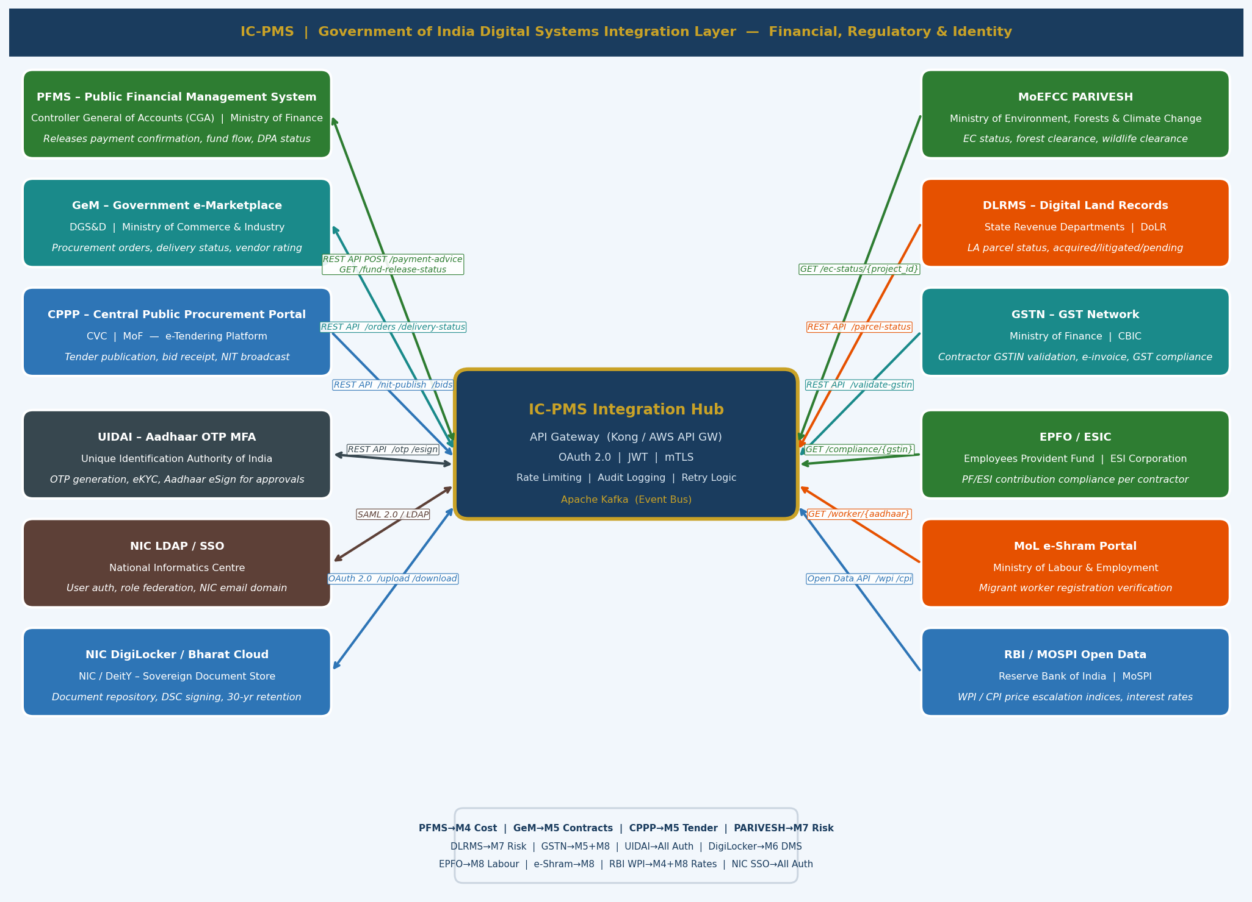
Figure 5.3 — Government of India Digital Systems Integration Layer

5.3.1 Financial Systems
PFMS — Public Financial Management System (Controller General of Accounts / Ministry of Finance)

PFMS is the mandatory payment disbursement platform for all Government of India expenditures above ₹ 1 Lakh. IC-PMS Module 4 (Cost Management) integrates with PFMS to submit Direct Payment Advice (DPA) for approved RA bills, receive payment confirmation, and reconcile fund releases against the PFMS Demand Numbers.
Integration Aspect | Specification
Integration Type | REST API — Bidirectional
Authentication | Mutual TLS (mTLS) client certificate issued by CGA; NICDC registered as a connected agency
Primary Endpoint | POST /cga/pfms/v3/dpa — Submit Direct Payment Advice for RA bill payment
Confirmation | GET /cga/pfms/v3/payment-status/{dpa_ref} — Poll payment confirmation; webhook callback on payment
Fund Flow | GET /cga/pfms/v3/fund-release/{demand_no} — Check NICDC fund release from Ministry of Finance
Data Format | PFMS-XML v3 schema; Ministry of Finance standard format for all connected agencies
DPA Content | NICDC account code, PAO code, DDO code, amount, contractor account details, LOA reference, bill no.
PFMS Demand Numbers | Pre-configured in Module 4 per corridor: 2217-Industrial Development-Capital Outlay (per head)
Reconciliation | Monthly: PFMS expenditure statement vs. Module 4 ACWP; reconciliation report auto-generated
Failure Handling | Retry 3× with exponential backoff; if PFMS unavailable > 2 hours: manual DPA submission form enabled; alert to NICDC Finance Director
Module Usage | Module 4 (Cost Management) — RA Bill Processing Step 8; Module 9 fund utilisation KPI

GeM — Government e-Marketplace (DGS&D / Ministry of Commerce & Industry)

GeM integration in IC-PMS supports procurement of goods and services that are available on the Government e-Marketplace. Works contracts (EPC, civil construction) are NOT procured through GeM — these go through CPPP e-tendering. However, procurement of equipment, IT hardware, vehicles, office supplies, and professional services available on GeM is routed through the GeM API integration in Module 5.
Integration Aspect | Specification
Integration Type | REST API — Bidirectional
Authentication | OAuth 2.0 Bearer Token; GeM buyer account registered for NICDC and each SPV
Create Order | POST /gem/v2/orders — Create purchase order for items available on GeM; linked to Module 5 procurement plan
Delivery Status | GET /gem/v2/orders/{order_id}/status — Sync delivery confirmation to Module 5 and Module 8 material receipt
Vendor Rating | GET /gem/v2/vendors/{gstin}/rating — Pull GeM vendor performance for Module 5 contractor scoring
Item Search | GET /gem/v2/products?category=[IT/Equipment] — Search available products for procurement planning
GFR Compliance | GFR Rule 149A mandates GeM for all eligible procurements; Module 5 enforces GeM route first-check before CPPP
Not in Scope | EPC works contracts, civil construction LOAs — these are procured through CPPP; GeM is for goods and services only
Module Usage | Module 5 (Contract Management) — Procurement Plan, GeM Order creation and tracking

CPPP — Central Public Procurement Portal (CVC / Ministry of Finance) | e-Tendering

All IC-PMS works contracts above ₹ 25 Lakh are procured through open competitive tendering published on the Central Public Procurement Portal (CPPP) as mandated by GFR Rule 158. Module 5's tender creation workflow auto-publishes NIT documents to CPPP and retrieves bid submission confirmations through the CPPP REST API.
Integration Aspect | Specification
Integration Type | REST API — Outbound (NIT publish); Inbound (bid receipt notification)
Authentication | API Key + NICDC institutional credentials registered with NIC/CPPP
NIT Publication | POST /cppp/v2/nit/publish — Publishes NIT in CPPP XML schema; NIT number confirmed by CPPP
Corrigendum | PUT /cppp/v2/nit/{nit_id}/corrigendum — Posts amendments to published NIT
Bid Receipt | GET /cppp/v2/nit/{nit_id}/bids — Retrieves submitted bid metadata; bid documents downloaded securely
NIT XML Schema | CPPP NIT Schema v2.1 — includes tender type, EMD, bid validity, eligibility criteria, BOQ reference
GFR Rule 158 | Mandatory e-publication on CPPP for all tenders > ₹ 25 Lakh; Module 5 blocks NIT release if CPPP publish fails
Integrity Pact | CVC mandates Integrity Pact for contracts > ₹ 10 Cr; Module 5 attaches IP document to CPPP tender package
Module Usage | Module 5 (Contract Management) — Tender Management tab, New Tender Form Step 5 (Review & Publish)

5.3.2 Regulatory & Compliance Systems
MoEFCC PARIVESH — Environmental & Forest Clearance Portal

Integration Aspect | Specification
Integration Type | REST API — Inbound (read-only)
Authentication | API Key issued by MoEFCC to NICDC; read-only scope
EC Status | GET /parivesh/v1/projects/{nicdc_proj_id}/ec-status — Returns: Approved/Pending/Under_Scrutiny/NOC_Required
Forest Clearance | GET /parivesh/v1/projects/{nicdc_proj_id}/forest-clearance — Stage 1/Stage 2 clearance status
Wildlife NOC | GET /parivesh/v1/projects/{nicdc_proj_id}/wildlife-noc — NBWL clearance status for projects in eco-sensitive zones
Polling Frequency | Weekly scheduled poll; real-time on project status change webhook (if PARIVESH webhook available)
Risk Integration | Status change (Approved → Suspended) automatically creates/upgrades regulatory risk in Module 7
Usage in IC-PMS | Module 7 (Risk Management) — Regulatory risk probability auto-updated; Module 9 — Compliance dashboard

DLRMS — Digital Land Records Management System (State Revenue Departments / DoLR)

Integration Aspect | Specification
Integration Type | REST API — Inbound (read-only); varies by state (Gujarat, Maharashtra, Rajasthan, etc.)
Data Retrieved | Land parcel status per survey number: Acquired / Litigated / Pending / Mutation_Complete
LA Risk Update | Real-time: when parcel status changes from 'Acquired' to 'Litigated', Module 7 LA risk probability auto-upgraded
Trigger Threshold | Risk trigger fires in Module 7 if: % litigated parcels > 10% of total project parcels for a WBS node
State Variations | Gujarat: ANYROR API | Maharashtra: MahaBhulekh API | Rajasthan: Apna Khata | UP: Bhulekh API | Others: Manual entry fallback
Polling Frequency | Weekly automated poll; manual trigger available for PMC on-demand
Module Usage | Module 7 (Risk Management) — Land Acquisition risk; Module 9 — LA dashboard widget

GSTN — GST Network (CBIC / Ministry of Finance)

Integration Aspect | Specification
Integration Type | REST API — Inbound (read-only)
Primary Use | GSTIN validation for all contractors, subcontractors, and suppliers in Modules 5 and 8
GSTIN Validation | GET /gstn/v1/validate?gstin={GSTIN} — Returns: Valid/Invalid, business name, state, registration date, status (Active/Cancelled/Suspended)
GST Compliance | GET /gstn/v1/compliance/{gstin} — Check if contractor has filed returns for last 3 months (3B compliance)
e-Invoice Verification | GET /gstn/v1/einvoice/{irn} — Verify e-invoice IRN before accepting material deliveries in Module 8
Trigger | New contractor registration in Module 5 triggers GSTIN validation; non-compliance flag blocks payment in Module 4
Frequency | On-demand validation at registration; monthly compliance check for all active contractors
Module Usage | Module 5 (Organisation Master, Contract Register), Module 8 (Subcontractor tracking), Module 4 (Bill Processing)

5.3.3 Identity & NIC Infrastructure
UIDAI — Aadhaar OTP Multi-Factor Authentication & eSign

Integration Aspect | Specification
Integration Type | REST API — Inbound (OTP generation); Bidirectional (eSign)
MFA Scope | All users with financial approval rights (Module 4 bill approval, Module 5 LOA award) require Aadhaar OTP as second factor
OTP API | POST /uidai/auth/otp — Sends OTP to Aadhaar-linked mobile; OTP valid for 10 minutes
OTP Verify | POST /uidai/auth/verify — Verifies OTP with Aadhaar number; returns auth token
Aadhaar eSign | POST /uidai/esign/v2 — Electronic signature on MPR (SPV Director), RA bills (PMC Lead); legally equivalent to wet ink signature under IT Act Section 3A
DSC Alternative | USB DSC Class 3 tokens accepted for NICDC HQ officers and Ministry officials; managed via NIC PKI
Privacy Compliance | Aadhaar number never stored in IC-PMS database; only auth tokens retained; compliant with UIDAI circular 2022
Module Usage | All modules — login MFA; Module 4 — RA bill financial approval; Module 9 — MPR SPV Director countersign

NIC DigiLocker / Bharat Cloud — Sovereign Document Repository

Integration Aspect | Specification
Integration Type | OAuth 2.0 API — Bidirectional
Storage Architecture | NIC DigiLocker as primary document store for Module 6 DMS; Bharat Cloud object storage (S3-compatible) as backup
Upload | POST /digilocker/v2/upload — Upload document with metadata: doc_type, project_ref, WBS_id, retention_class, classification
Download | GET /digilocker/v2/documents/{doc_id} — Pre-signed URL with 1-hour expiry; no permanent public URLs
DSC Signing | POST /digilocker/v2/sign — Integrated digital signature on documents; supports Class 3 DSC and Aadhaar eSign
Retention Classes | Permanent (MPR, LOA, Satellite records) | Long-term 30yr (RA bills, GFR mandate) | Medium 7yr (Correspondence)
WORM Storage | Write-Once-Read-Many storage for financial documents; compliant with GFR 2017 Rule 33 (30-year retention)
Module Usage | Module 6 (DMS — all documents), Module 4 (RA bill archives), Module 9 (MPR archive), Module 5 (Contract documents)

5.3.4 Labour Compliance Systems
System | Ministry | Integration Type | Data Retrieved | IC-PMS Module
EPFO Portal | Ministry of Labour | REST API — Inbound (read-only) | PF/ESI contribution compliance status per contractor GSTIN: Current / Arrear (30+ days) / Defaulter | Module 8 — Labour Log; Module 5 — Contractor compliance
ESIC Portal | Ministry of Labour | REST API — Inbound | ESI contribution status; employee count per contractor at establishment level | Module 8 — Labour compliance tracking
MoL e-Shram Portal | Ministry of Labour | REST API — Inbound | Migrant worker registration verification for applicable states (BOCW Act); worker Aadhaar-linked UAN | Module 8 — Labour compliance; Worker registration tracking
RBI Open Data (WPI) | Reserve Bank of India | Open Data API — Inbound | Wholesale Price Index monthly data for CPWD SOR rate escalation computation in Module 8 | Module 8 — Effective rate computation; Module 4 — Escalation clauses
MoSPI MOSPI CPI | Ministry of Statistics | Open Data API — Inbound | Consumer Price Index for labour rate escalation | Module 8 — Labour rate escalation

5.4 Satellite & Geospatial Integration Pipeline
The satellite integration pipeline is the most technically complex integration in IC-PMS — it ingests high-resolution satellite imagery from ISRO and commercial providers, processes it through an AI/ML segmentation pipeline, and produces AI-verified construction progress metrics that are used across Modules 3, 4, 7, and 9. The pipeline runs on NIC MeghRaj GPU infrastructure and is architecturally separated from the IC-PMS operational services to prevent compute-intensive processing from impacting application response times.
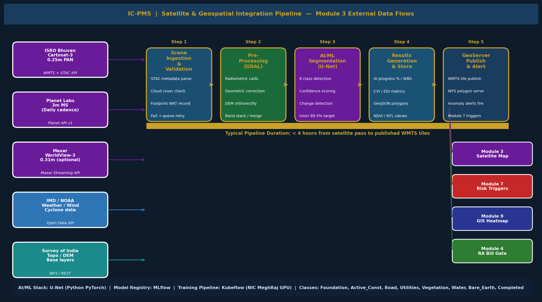
Figure 5.4 — Satellite & Geospatial Integration Pipeline (Ingestion → Pre-processing → AI/ML → Results → GeoServer)

5.4.1 Satellite Data Sources
Source | Provider | Product | Resolution | Spectral Bands | API Protocol | Cadence | Cost Model
ISRO Bhuvan | National Remote Sensing Centre (NRSC), ISRO | Cartosat-3 Level-2 product | 0.25m PAN; 1.0m MS | PAN + 4 multispectral | WMTS + STAC API; ISRO Bhuvan portal SSO | Weekly to fortnightly (cloud permitting) | Government allocation — no commercial cost
Planet Labs | Planet Labs (US commercial) | Planet Scope 3m MS; SkySat 50cm PAN (optional) | 3m MS; 50cm PAN | RGB + NIR; or 8-band | Planet API v1 (REST/JSON); OAuth 2.0 | Daily 3m coverage; weekly 50cm | NIC MoU / MeitY agreement
Maxar WorldView | Maxar Technologies (optional upgrade) | WorldView-3 30cm PAN | 0.31m PAN; 1.24m MS | Panchromatic + 8MS + SWIR | Maxar Streaming API | On-demand tasking | Per km2 commercial pricing — budget permitting
IMD / NOAA Weather | India Meteorological Department | Weather forecast, cyclone alerts, monsoon onset | Regional | N/A | IMD OpenData REST API | Daily / Real-time alerts | Free government data
Survey of India | National Survey Organisation | 1:10,000 topo sheets; DEM (CARTODEM) | 1m DEM resolution | Topographic + DEM | WFS / GeoServer WMS | Periodic updates | Government allocation

5.4.2 AI/ML Segmentation Pipeline
Pipeline Stage | Technology | Input | Output | Duration
Stage 1 — Ingestion & Validation | Python (requests, boto3); MinIO S3-compatible storage | Raw imagery files from ISRO STAC / Planet API | Validated raw scenes in MinIO; metadata in PostgreSQL; cloud cover check passed | 15–30 minutes
Stage 2 — Pre-processing | Python GDAL + Rasterio; SRTM/CARTODEM DEM | Raw GeoTIFF scenes | Radiometrically calibrated, orthorectified, cloud-masked, band-stacked GeoTIFF | 30–45 minutes
Stage 3 — AI Segmentation (U-Net) | PyTorch U-Net architecture (semantic segmentation); NIC MeghRaj GPU cluster (A100) | Pre-processed GeoTIFF + DPR boundary GeoJSON | Pixel-level classification map (8 classes); confidence raster; WBS polygon-level progress % | 45–90 minutes
Stage 4 — Analytics Computation | Python (NumPy, GeoPandas); PostGIS SQL | Classification raster + WBS polygons | CVI (Construction Velocity Index), EDI (Equipment Density Index), NDVI, NTL for each WBS element | 15 minutes
Stage 5 — GeoServer Publish & Alert | GeoServer 2.23 (OGC WMS/WMTS/WFS); Kafka producer | Analytics results + classification rasters | WMTS tiles served to Module 3 map; WFS polygons with AI progress attributes; Kafka alert events | 15 minutes

AI Model Detail | Specification
Architecture | U-Net (encoder-decoder) with ResNet-50 backbone; adapted for multi-temporal change detection
Training Dataset | 3,500 labelled satellite scenes across NHAI, NICDC pilot corridors; augmented with global construction site data
Classes (8) | (0) Background/Non-construction | (1) Active Construction | (2) Road/Pavement | (3) Foundation/Structure | (4) Utilities | (5) Vegetation | (6) Bare Earth | (7) Completed/As-Built
Accuracy | Mean Intersection over Union (mIoU): 89.4% on DMIC test scenes | Confusion matrix published in Model Registry
Model Registry | MLflow on NIC MeghRaj; model versions tracked; champion/challenger A/B testing for production deployments
Training Pipeline | Kubeflow Pipelines on NIC MeghRaj Kubernetes; triggered on new training data availability; GPU: NVIDIA A100 80GB
Inference | NIC MeghRaj GPU cluster; batch inference per satellite scene; < 90 minutes per scene for full corridor node

5.5 API Architecture & Security Framework
IC-PMS implements a zero-trust security architecture — no integration endpoint is trusted by default, regardless of whether it originates inside or outside the NIC MeghRaj perimeter. Every API call is authenticated, authorised, rate-limited, logged, and encrypted. The API Gateway (Kong) is the single enforcement point for all these controls.
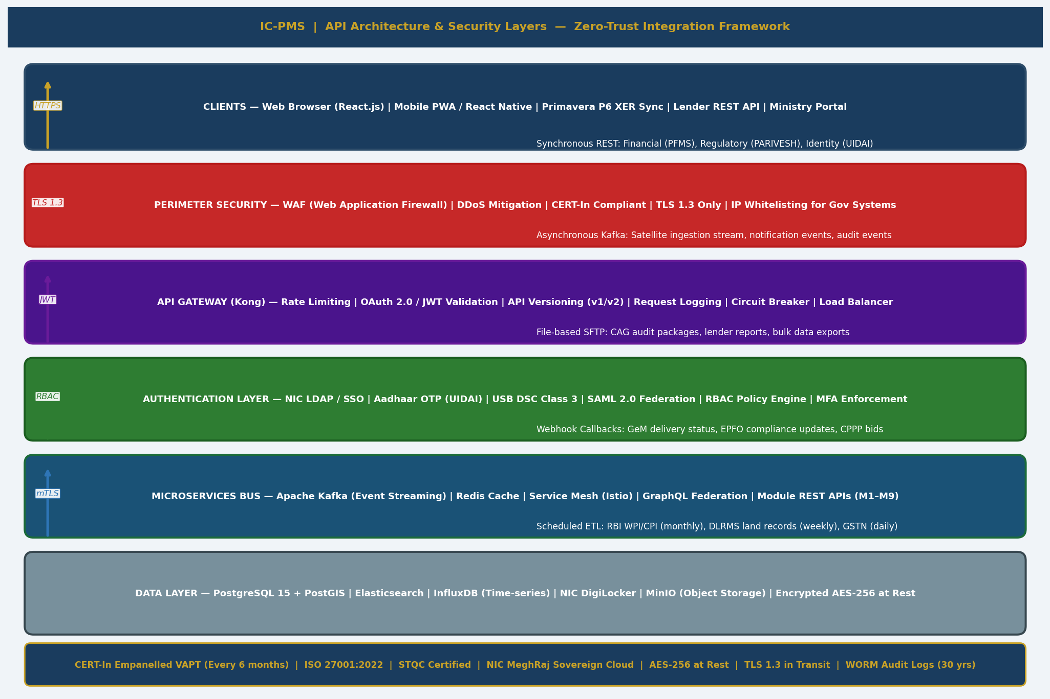
Figure 5.5 — API Architecture & Security Layers (Zero-Trust Framework — WAF → Gateway → Auth → Bus → Data)

5.5.1 API Gateway Configuration (Kong)
Kong Plugin / Feature | Configuration | Purpose
Rate Limiting | IC-PMS internal APIs: 10,000 req/min; External GoI APIs: per SLA; Satellite: 100 req/hr | Prevent DoS; protect external system quotas
OAuth 2.0 / JWT Validation | Token introspection against NIC LDAP; JWT expiry 8 hours for session; 30 minutes for financial operations | Token-based stateless authentication for all API requests
API Versioning | v1 (stable) and v2 (current); v3 (beta); consumers specify version in URL prefix /api/v2/ | Backward compatibility during system upgrades
Request Logging | All requests logged to Elasticsearch: endpoint, user_id, response_time, status_code, IP, corridor_scope | Full audit trail; Elasticsearch queryable for incident investigation
Circuit Breaker | Opens circuit after 5 consecutive failures to an upstream; 30-second wait before retry; fallback response configured | Prevents cascade failure when GoI systems are unavailable
mTLS for GoI Systems | Client certificates (PFMS, GSTN, PARIVESH): mandatory mutual TLS authentication for financial/regulatory integrations | Ensures only NICDC-registered systems can call these endpoints
IP Whitelisting | PFMS: CGA server IPs only; GSTN: CBIC registered ranges; UIDAI: UIDAI designated endpoints | Restricts government system APIs to known IP ranges
Transformation | XER → JSON transformation for Primavera P6; PFMS-XML → JSON for internal use; field mapping per integration | Protocol/format translation at gateway level

5.5.2 Authentication Protocol Summary
Integration | Auth Protocol | Credential Type | Token Lifetime | MFA Required
IC-PMS User Login | NIC SSO + Aadhaar OTP | NIC LDAP credentials + Aadhaar OTP | 8 hours session JWT | Yes — Aadhaar OTP for all users
Financial Approvals (M4 RA Bills) | Aadhaar eSign or USB DSC Class 3 | Biometric/OTP (Aadhaar) or hardware token (DSC) | Per-transaction (30-min window) | Yes — mandatory for all financial approvals
PFMS API (CGA) | Mutual TLS (mTLS) | Client X.509 certificate issued by CGA | Certificate: 1 year; session: 30 minutes | Yes — certificate serves as MFA
GeM Portal | OAuth 2.0 Bearer Token | Client ID + Secret (GeM buyer account) | 1 hour (auto-refresh) | No — token-based authentication sufficient
UIDAI Aadhaar OTP | API Key + HMAC signature | NICDC AUA API Key issued by UIDAI | OTP: 10 minutes; API Key: 1 year | N/A — this IS the MFA provider
NIC DigiLocker | OAuth 2.0 Authorization Code | User consent flow; NICDC client credentials | Access: 1 hour; Refresh: 30 days | Aadhaar OTP for DigiLocker consent
Oracle Primavera P6 | REST API Key + JWT | P6 API key + user JWT from P6 server | JWT: 1 hour | No — P6 handles its own auth
Satellite APIs (Planet, ISRO) | API Key (Planet) / SSO (ISRO Bhuvan) | Planet API key; ISRO institutional account | API Key: permanent (rotated annually) | No — key-based auth for server-to-server

5.5.3 Security Certifications & Compliance
Security Requirement | Standard / Mandate | IC-PMS Implementation
Vulnerability Assessment & Penetration Testing | CERT-In empanelled agency; mandatory every 6 months for government websites/applications | VAPT conducted before production go-live and every 6 months thereafter; CERT-In empanelled agency engaged through open tender
Information Security Management | ISO 27001:2022 | NICDC to seek ISO 27001 certification for IC-PMS within 18 months of go-live; Annex A controls implemented in system design
Encryption at Rest | IT Act 2000; MeitY guidelines | AES-256 encryption for all database volumes (PostgreSQL, Elasticsearch, MinIO); key management via NIC KMS
Encryption in Transit | TLS 1.3 mandatory; TLS 1.2 deprecated | All IC-PMS endpoints HTTPS only; TLS 1.0/1.1 disabled; HSTS headers enforced; certificate from NIC CA
Audit Logging | GFR 2017 Rule 33; CVC guidelines | WORM (Write-Once-Read-Many) audit log in Elasticsearch; all user actions, data changes, and API calls logged; 30-year retention per GFR mandate
Data Localisation | MeitY Data Localisation Policy | All IC-PMS data hosted exclusively on NIC MeghRaj (NIC data centres in Pune, Hyderabad); no data in foreign clouds
PII Protection | PDPB (Personal Data Protection Bill framework) | Aadhaar numbers never stored; contractor worker Aadhaar referenced by UID token only; PII masked in test/UAT environments
Software Composition Analysis | CERT-In Secure Coding guidelines | SAST (SonarQube) in CI/CD pipeline; DAST (OWASP ZAP) in staging; dependency vulnerability scan (Snyk) weekly

5.6 Financial Integration Flows — PFMS, GeM, CPPP
The financial integration flows are the most governance-critical integrations in IC-PMS — they connect the system to the Government of India's fund management infrastructure. Every rupee of expenditure from NICDC's industrial corridor programme must pass through the PFMS payment gateway, and all public procurement must be traceable to either GeM or CPPP. The following diagram and specifications detail these flows precisely.
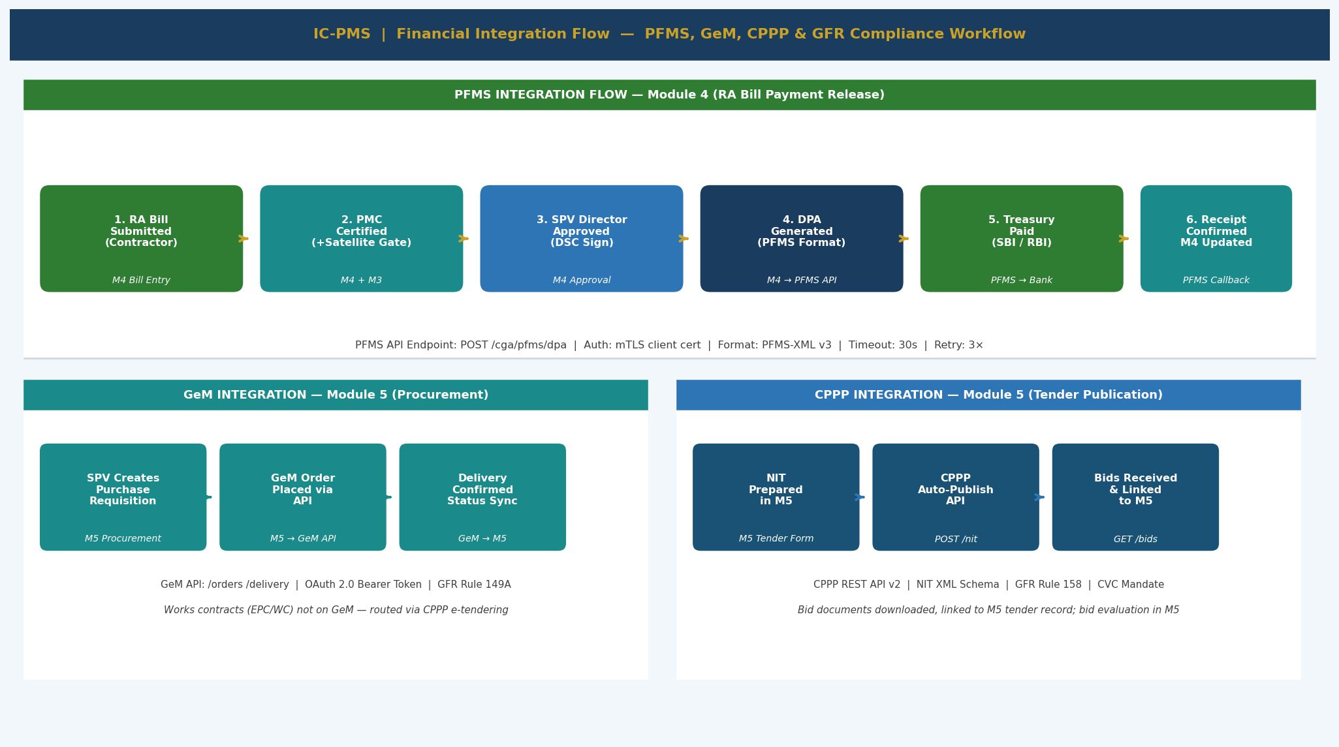
Figure 5.6 — Financial Integration Flow (PFMS 8-Step RA Bill Pipeline, GeM Procurement, CPPP Tendering)

5.6.1 PFMS End-to-End Payment Flow
- Contractor submits RA Bill in IC-PMS Module 4, claiming measured quantities from the Measurement Book (MB). Bill entry captures LOA reference, WBS package, gross amount, period, and contractor's claimed % complete.
- PMC Engineer verifies the MB measurements independently; records certified quantities. System computes BCWP for the certified period.
- Satellite Gate (Module 3 integration): IC-PMS queries the latest AI-verified progress % for the WBS polygon. If AI% < Contractor Claimed% – 5%, bill is placed on HOLD. PMC must provide field inspection override with date and physical evidence.
- PMC Lead digital signature (Aadhaar eSign) certifies the bill at PMC-approved %. Bill moves to SPV Director queue.
- Deductions computed automatically: Mobilisation Advance Recovery (per LOA schedule), Retention (5%), Liquidated Damages (if applicable, per LOA), TDS (2%), and GST (18% added to net). Net Payable computed.
- SPV Director approves via USB DSC Class 3 signature. This is the final internal approval.
- IC-PMS generates PFMS Direct Payment Advice (DPA) in PFMS-XML v3 format. DPA includes: NICDC DDO code, PAO code, contractor bank account (validated against PFMS contractor master), Demand No. 2217, bill reference, amount in words and figures.
- DPA submitted to PFMS via POST /cga/pfms/v3/dpa. PFMS validates, routes to PAO, processes treasury payment via RBI/SBI. PFMS sends payment confirmation callback to IC-PMS. Module 4 ACWP updated. Module 9 fund utilisation KPI updated.

5.6.2 GFR Compliance Checkpoints
GFR Rule | Requirement | IC-PMS Enforcement
GFR Rule 210 | MB measurements mandatory before payment | System blocks RA bill advancement past Step 2 if MB entries not completed
GFR Rule 212 | PMC certification of measurements mandatory | PMC Lead digital signature required at Step 4; cannot be bypassed
GFR Rule 149 | Open competitive tender for purchases > ₹ 25 Lakh | Module 5 enforces CPPP route; blocks direct award without tender for eligible value
GFR Rule 149A | GeM procurement mandatory for listed goods/services | Module 5 first-check: is item available on GeM? If yes, GeM route enforced
GFR Rule 158 | CPPP e-publication mandatory for tenders > ₹ 25 Lakh | Module 5 blocks NIT release without CPPP publish confirmation
GFR Rule 147 | Retention deduction minimum 5% of contract value | System auto-applies 5% retention; override requires Finance Director approval
GFR Rule 205 | VO limit 10% of LOA value without fresh approval | Module 5 alerts at 8%, blocks at 10%; NICDC Board approval workflow triggered
GFR Rule 33 | All financial records retained 30 years | DigiLocker WORM storage with 30-year retention class for all financial documents

5.7 Oracle Primavera P6 / Unifier Integration
IC-PMS does not replace Primavera P6 or Primavera Unifier for organisations that already use them. Instead, IC-PMS acts as the Indian government governance and compliance layer — adding GFR audit trails, PFMS payment integration, Aadhaar authentication, satellite verification, and regulatory compliance — over the P6/Unifier scheduling and cost management core. Bidirectional data exchange ensures that P6 users can continue using their native tools while IC-PMS aggregates the data for government reporting.
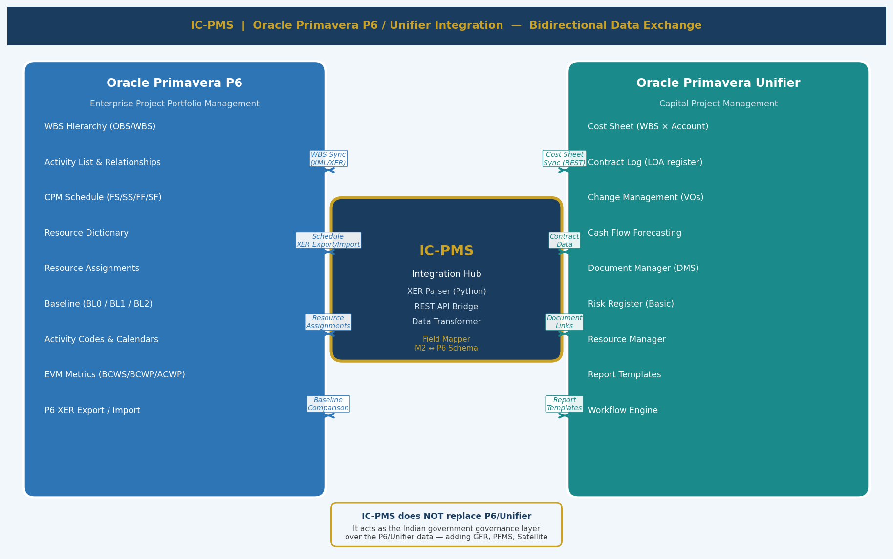
Figure 5.7 — Oracle Primavera P6 / Unifier Bidirectional Integration Architecture

5.7.1 Primavera P6 Integration Specification
Integration Aspect | Specification
Integration Type | XER (P6 proprietary format) + REST API (P6 EPPM Server)
Authentication | P6 API key + JWT from P6 EPPM server; NIC proxy server maintains P6 service account
WBS Synchronisation | IC-PMS WBS → P6 via POST /api/v2/wbs; P6 WBS → IC-PMS via XER import; field mapping: wbs_id ↔ P6 WBS Code
Activity Export to IC-PMS | P6 XER export (Activities + Relationships + Resources) → IC-PMS XER Parser → Module 2 activity table; on-demand or scheduled
Schedule Import from IC-PMS | IC-PMS generates XER file from Module 2 data → P6 XER import; preserves activity IDs, constraints, calendars
Resource Dictionary | P6 Resource Dictionary → IC-PMS Resource Library (Module 8) via XER resource section; rates overridden by CPWD SOR in IC-PMS
Baseline Export | P6 BL0 baseline → IC-PMS Module 2 BL0 via XER; IC-PMS supports up to 3 baselines per project, matching P6
EVM Reconciliation | BCWP from IC-PMS (AI-verified %) compared against P6 EVM (P6 % complete); discrepancies flagged in Module 9
Calendar Mapping | P6 custom calendars → IC-PMS Calendar Master; holiday definitions synced; state-specific calendars maintained in IC-PMS
Field Mapping | P6 Activity ID ↔ IC-PMS activity_id; P6 WBS Code ↔ IC-PMS wbs_code; P6 Resource Code ↔ IC-PMS resource_code

5.7.2 Primavera Unifier Integration Specification
Integration Aspect | Specification
Integration Type | REST API — Bidirectional (Unifier Integration Framework)
Authentication | Unifier API token + NICDC Unifier service account; OAuth 2.0 for user-facing integrations
Cost Sheet Sync | Unifier Cost Sheet (WBS × Account matrix) → IC-PMS Module 4 budget structure; WBS and account code mapping configured in integration layer
Contract Data | Unifier Contract Log (LOA register) ↔ IC-PMS Module 5; contract status, award date, final amount synced bidirectionally
Change Management (VOs) | Unifier Change Orders → IC-PMS Module 5 VO Register; VO status and value synced; GFR 10% limit check enforced in IC-PMS
Document Exchange | Unifier Document Manager → IC-PMS Module 6 DMS; drawings and specifications synced; IC-PMS DMS is primary for government documents
Report Templates | Unifier BI report templates adapted for IC-PMS; NICDC-customised reports in IC-PMS supersede Unifier reports for government use
Limitations | Aadhaar authentication, PFMS integration, Satellite Gate, GFR compliance enforcement — these exist only in IC-PMS, not Unifier

5.8 Event-Driven Integration — Apache Kafka Event Bus
IC-PMS uses Apache Kafka as the event bus for all asynchronous inter-module communication and external system event handling. Kafka decouples modules from each other — when Module 2's schedule engine advances the data date, it publishes an event to Kafka rather than calling Modules 4, 7, and 9 directly. Each consuming module subscribes to the relevant topics and processes events independently, at its own pace, without blocking the producer.
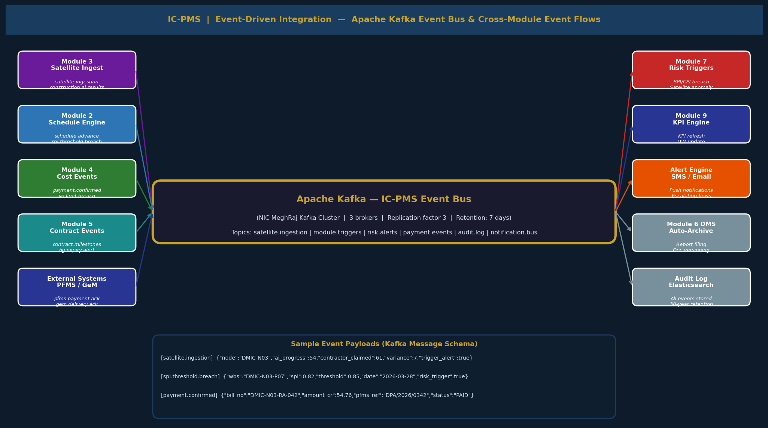
Figure 5.8 — Apache Kafka Event Bus (Producers, Topics, Consumers, Sample Payloads)

5.8.1 Kafka Cluster Configuration
Configuration Parameter | Specification
Deployment | NIC MeghRaj Kubernetes cluster; Strimzi Kafka Operator for Kubernetes-native management
Brokers | 3 Kafka brokers (NIC MeghRaj VM instances); replication factor = 3 for all production topics
Retention | Default: 7 days; Audit log topic: 10 years (Kafka log compaction + archival to Bharat Cloud)
Security | SASL/SCRAM authentication for producers/consumers; TLS 1.3 inter-broker and client encryption; ACLs per service account
Monitoring | Kafka JMX metrics → Prometheus → Grafana dashboard; consumer lag alerting (threshold: > 1,000 messages)
Throughput | Designed for: 50,000 messages/hour normal; 500,000 messages/hour during satellite processing peak

5.8.2 Kafka Topic Catalogue
Topic Name | Producer(s) | Consumer(s) | Message Rate | Message Content Summary
satellite.ingestion | Module 3 Pipeline (Python) | Module 3 Map Viewer, Module 9 DW ETL | ~10/week (per scene) | scene_id, wbs_id, source, ai_progress_pct, cloud_cover, timestamp
construction.ai.results | Module 3 AI Engine | Module 7 Risk Triggers, Module 4 Satellite Gate, Module 9 KPI Engine | ~50/week | wbs_id, ai_pct, contractor_claimed_pct, variance, encroachment_alert, cvi, edi
schedule.spi.breach | Module 2 Scheduling Engine | Module 7 Risk Triggers, Module 9 Alert Engine | ~20/day | wbs_id, spi_value, threshold, data_date, consecutive_breach_count
schedule.data.advance | Module 2 Scheduling Engine | Module 4 (EVM), Module 8 (resource), Module 9 (DW ETL) | 1/day (on advance) | data_date_new, corridors_affected, activities_updated_count
payment.confirmed | Module 4 Cost (PFMS callback) | Module 9 (fund utilisation KPI), Module 5 (contract payment log), Audit Log | ~50/day | bill_no, loa_no, amount_cr, pfms_ref, payment_date, wbs_id
payment.events | Module 4 | Module 9 Dashboard, Audit Log | ~200/day | All RA bill state transitions: submitted, certified, approved, PFMS_submitted, paid, rejected
risk.alerts | Module 7 Alert Engine | Module 9 Alert Centre, SMS/Email Notification Service | ~30/day (varies) | risk_id, alert_type, severity, wbs_id, escalation_target, message
contract.milestones | Module 5 Contract Engine | Module 7 (milestone risk), Module 9 (milestone KPI) | ~20/day | loa_no, milestone_type, due_date, actual_date, status, delay_days
bg.expiry.alerts | Module 5 BG Monitor (daily job) | Module 7 Risk, Module 9 Alerts, Email Service | ~5/day | loa_no, bg_type, bg_expiry_date, days_remaining, renewal_status
module.triggers | All modules | Module 7 Risk Management (trigger processor) | ~100/day | source_module, trigger_type, wbs_id, value, threshold, timestamp, severity
notification.bus | All modules | Email Service (SMTP), SMS Sevak API, In-app notification store | ~500/day | recipient_role, message_type, priority, content_json, delivery_channels
audit.log | All modules, API Gateway | Elasticsearch (immutable audit store) | ~10,000/day | user_id, action, entity_type, entity_id, before_state, after_state, timestamp, ip_address

5.8.3 Event Schema Standards
All Kafka messages in IC-PMS follow the CloudEvents v1.0 specification — a CNCF standard for event data that ensures interoperability and consistent audit logging. Every message includes a standard envelope with: specversion, id (UUID), source (module URL), type (event type string), time (ISO 8601), datacontenttype (application/json), and the event-specific data payload.
CloudEvents Field | IC-PMS Convention | Example
specversion | Always '1.0' | "specversion": "1.0"
id | UUID v4 — unique per message | "id": "550e8400-e29b-41d4-a716-446655440000"
source | URL format: /icpms/{module}/{service} | "source": "/icpms/m3/satellite-pipeline"
type | com.nicdc.icpms.{module}.{event} | "type": "com.nicdc.icpms.m3.ai.progress.updated"
time | ISO 8601 UTC timestamp | "time": "2026-03-28T14:32:00Z"
datacontenttype | Always application/json | "datacontenttype": "application/json"
subject | WBS ID or entity ID the event relates to | "subject": "DMIC-N03-P07"
data | Event-specific JSON payload — module-defined schema | "data": {"ai_progress_pct": 54, "variance": 7, ...}

5.9 Integration Error Handling & Resilience
The most critical design requirement for IC-PMS integration is: no single external system failure should prevent IC-PMS operations. A PFMS outage should not stop the RA bill review process. A PARIVESH API outage should not block risk register updates. An ISRO satellite delivery delay should not prevent schedule updates. This resilience is achieved through a combination of Circuit Breakers, manual fallback forms, graceful degradation, and Kafka-based asynchronous retry.

5.9.1 Circuit Breaker Configuration
Integration | Failure Threshold | Circuit Open Duration | Fallback Behaviour | Alert Triggered
PFMS (CGA) | 5 consecutive failures in 60 seconds | 30 minutes | Manual DPA form enabled in Module 4; PMC Finance notified; Finance Director alert | P2 Urgent — NICDC Finance Director + NICDC IT
GeM Portal | 3 consecutive failures | 15 minutes | Manual procurement entry form; GeM order tracked outside IC-PMS until API restored | P3 Warning — Module 5 admins
CPPP e-Procurement | 3 consecutive failures | 15 minutes | Draft NIT created locally; CPPP publish queued for auto-retry on circuit close | P3 Warning — Module 5 admins
UIDAI Aadhaar OTP | 2 consecutive failures | 10 minutes (retry every 2 minutes) | DSC token alternative enabled; email OTP fallback for non-financial operations | P2 Urgent — all affected users notified
PARIVESH / DLRMS | 10 consecutive failures | 1 hour | Manual clearance status update form in Module 7; last known status retained with staleness warning | P4 Info — Module 7 risk team
ISRO Bhuvan Satellite | Unavailability of new scenes > 14 days | N/A (data-dependent) | Module 3 uses last available scene; 'Stale Data' warning on all Module 3 views | P3 Warning — Module 3 PMC Lead
Oracle Primavera P6 | 3 consecutive XER/REST failures | 30 minutes | Manual schedule entry in Module 2; P6 sync queued; P6 users continue working independently | P3 Warning — PMC Planning Lead
NIC DigiLocker | 5 consecutive failures | 15 minutes | Documents cached locally in MinIO; upload to DigiLocker queued and retried | P3 Warning — Module 6 DMS admin

5.9.2 Data Quality & Validation Framework
Validation Type | What is Checked | Where Enforced | Action on Failure
Schema validation | Every inbound API response validates against JSON Schema before being processed | API Gateway (Kong) + application layer | Reject message; alert to integration admin; log to Elasticsearch
Field completeness | Mandatory fields in module data entries validated before saving | Form-level (frontend + backend) | Blocking validation — user cannot save incomplete records
Cross-module consistency | WBS code in Module 2 activity must exist in Module 1; Resource code in M8 must exist in Resource Library | Business logic layer on save | Blocking validation with error message referencing the required master data
PFMS DPA accuracy | DPA amount must equal IC-PMS computed Net Payable; DDO code must be in approved list | Module 4 pre-submission check | Blocking — DPA not submitted until amount reconciles
Satellite AI confidence | AI segmentation confidence score must be > 70% for AI progress % to be used in automated gate | Module 3 pipeline (post-inference) | Low-confidence scenes flagged as 'Manual Review Required'; AI% not used in billing gate
ETL data freshness | DW data for each module must not be > 48 hours old for dashboard display | Module 9 ETL monitor (Airflow health check) | Stale data warning on dashboards; alert to NICDC IT; forced ETL retry triggered

5.9.3 Integration Monitoring & Observability
Monitoring Tool | What it Monitors | Dashboard Location | Alert Threshold
Prometheus + Grafana | API Gateway metrics: req/sec, error rate, latency P95/P99; Kafka consumer lag; ETL job duration | NIC MeghRaj Operations Centre | API error rate > 1%; P95 latency > 3s; consumer lag > 1,000 messages
Apache Airflow UI | ETL pipeline health: last run status, duration, row counts, failed tasks | IC-PMS Admin → Integration → ETL Monitor | Any failed Airflow DAG task; ETL duration > 2× normal
Elasticsearch (APM) | Application-level traces: API call chains, external system call times, database query times | IC-PMS Admin → Integration → APM Traces | External API call > 10 seconds; database query > 5 seconds
Kafka Manager (Kafdrop) | Kafka broker health, topic offsets, consumer group lag, message rates | IC-PMS Admin → Integration → Kafka Monitor | Broker disk > 80%; consumer lag > 5,000; replication lag > 1,000
Synthetic Monitoring (Pingdom) | Availability of all IC-PMS production endpoints; end-to-end login flow; key API health checks | NIC IT Operations Centre | Any endpoint unavailable > 2 minutes; login flow failure

5.10 Complete Integration Register
The following table is the authoritative register of all IC-PMS integrations — both inter-module (internal) and external. It serves as the integration reference for System Integrators, NICDC IT, and NIC teams.

5.10.1 External System Integration Register
# | System | Category | Direction | Protocol | Auth Method | IC-PMS Module(s) | SLA / Fallback
1 | PFMS (CGA) | Financial | Bidirectional | REST + PFMS-XML | mTLS Client Cert | M4 Cost | Manual DPA form fallback
2 | GeM Portal | Procurement | Bidirectional | REST/JSON | OAuth 2.0 Bearer | M5 Contracts | Manual order entry
3 | CPPP / e-Procurement | Procurement | Outbound | REST + NIT XML | API Key | M5 Tenders | Draft NIT local; queued publish
4 | MoEFCC PARIVESH | Regulatory | Inbound (read) | REST/JSON | API Key (read-only) | M7 Risk | Manual clearance update
5 | DLRMS (State Land Records) | Regulatory | Inbound (read) | REST/JSON (state APIs) | API Key per state | M7 Risk | Manual LA status update
6 | GSTN | Compliance | Inbound (read) | REST/JSON | API Key (CBIC) | M5 Org, M8 Labour | Manual GSTIN verify
7 | UIDAI Aadhaar OTP | Identity / Auth | Bidirectional | REST/JSON | NICDC AUA API Key | All modules (auth) | DSC + email OTP fallback
8 | NIC LDAP / SSO | Identity / Auth | Bidirectional | LDAP + SAML 2.0 | Client credentials | All modules (auth) | Local auth fallback
9 | NIC DigiLocker | Document Storage | Bidirectional | OAuth 2.0 REST | Access + Refresh token | M6 DMS, M4, M9 | MinIO local cache; queued sync
10 | NIC e-Office | Workflow | Outbound | REST/JSON | JWT | M5, M7 (approvals) | Email notification fallback
11 | NIC SMS Sevak | Notification | Outbound | REST/JSON | DLT Sender ID | M7, M9 Alerts | Email fallback
12 | EPFO Portal | Labour | Inbound (read) | REST/JSON | API Key | M8 Resources | Manual compliance entry
13 | ESIC Portal | Labour | Inbound (read) | REST/JSON | API Key | M8 Resources | Manual compliance entry
14 | MoL e-Shram | Labour | Inbound (read) | REST/JSON | API Key | M8 Resources | Manual worker reg. entry
15 | RBI Open Data (WPI/CPI) | Financial Rates | Inbound (read) | Open Data REST | API Key (optional) | M4, M8 Rates | Manual rate update
16 | ISRO Bhuvan / Cartosat-3 | Satellite | Inbound | WMTS + STAC API | SSO (Institutional) | M3 Satellite | Last scene retained; manual upload
17 | Planet Labs | Satellite | Inbound | Planet API v1 REST | Planet API Key | M3 Satellite | ISRO fallback
18 | Maxar WorldView | Satellite (optional) | Inbound | REST/JSON | Client Key | M3 Satellite | Optional; not on critical path
19 | IMD Weather Data | Environmental | Inbound | REST/JSON | API Key (IMD) | M7 Risk (monsoon) | Manual weather entry
20 | Survey of India (DEM/Topo) | Geospatial | Inbound | WFS / REST | Institutional account | M3 GIS base layers | Static DEM pre-loaded; updates annually
21 | Oracle Primavera P6 | PM Tool | Bidirectional | XER + REST API | P6 API Key + JWT | M2 Schedule, M8 Resources | IC-PMS native entry
22 | Oracle Primavera Unifier | PM Tool | Bidirectional | REST API (Unifier IF) | OAuth 2.0 | M4 Cost, M5 Contracts | IC-PMS native entry
23 | CAG Digital Audit System | Audit | Outbound | SFTP (Secure) | SSH key + certificate | M4, M6, M9 Reporting | Encrypted package; manual delivery
24 | Lenders (ADB/JICA/WB) | Reporting | Outbound | REST API + SFTP | API key + lender cert | M9 Reports | Manual report delivery via email
25 | Ministry of Commerce PIMS | Reporting | Outbound | REST API | PIMS API key | M9 Reports | Manual data submission

5.10.2 Inter-Module Integration Summary
Integration | From | To | Data Exchanged | Mechanism | Frequency
WBS to Schedule | M1 | M2 | WBS hierarchy, phase/status, start/completion dates | REST API (on publish) + DW sync | On WBS publish; daily
WBS to Cost | M1 | M4 | WBS cost account codes, PFMS Demand No., budget ceiling | REST API | On WBS publish
WBS to Risk | M1 | M7 | WBS linkage for risk records, OBS organisation | REST API | Real-time on risk save
WBS to Resources | M1 | M8 | WBS resource pool allocation, package calendar | REST API | Daily
Schedule EVM → Cost | M2 | M4 | BCWP per activity (% complete × BAC), schedule milestones | Kafka: schedule.data.advance + REST | Daily on data advance
Cost ACWP → Schedule | M4 | M2 | ACWP from RA bill payments, resource cost actuals | REST API | On RA bill approval; daily
Satellite AI → Schedule Gap | M3 | M2 | AI progress % vs Contractor claimed — discrepancy flag | Kafka: construction.ai.results | Weekly (per satellite scene)
Satellite → Risk Triggers | M3 | M7 | Encroachment, idle zone, NDVI exceedance alerts | Kafka: module.triggers | Real-time (on anomaly detection)
Cost VO → Risk | M4 | M7 | CPI breach, VO % approaching limit triggers | Kafka: module.triggers | Daily; real-time on threshold breach
Contract Score → Risk | M5 | M7 | Contractor performance scorecard < 60 trigger | Kafka: module.triggers | Monthly scorecard compute + real-time trigger
Contract → Cost | M5 | M4 | LOA value, deduction rates, BG expiry, VO approvals | REST API (bidirectional) | On contract event; daily
Documents → Cost | M6 | M4 | Drawing IFC confirmation gating bill for drawing-dependent activities | REST API | On IFC status change
All Modules → Reports | M1–M8 | M9 | All programme data via ETL to Data Warehouse | Apache Airflow ETL | Per-module frequency (15min to daily)
Risk → Reports | M7 | M9 | Risk register, MC P80, trigger log, opportunity register | Airflow ETL + real-time Kafka | Daily ETL; real-time for P1/P2 alerts
Reports → DMS | M9 | M6 | Published MPRs, custom reports, lender reports auto-archived | REST API (DMS upload) | On each report publication

5.11 NeSDA Compliance & Integration Standards
All IC-PMS integrations are designed to comply with the National e-Governance Service Delivery Assessment (NeSDA) framework published by MeitY, which defines standards for government digital services including API design, data sharing, security, and availability.

5.11.1 NeSDA Alignment
NeSDA Principle | IC-PMS Implementation
API First | All IC-PMS capabilities exposed as documented REST APIs; OpenAPI (Swagger) specification published for all endpoints; enables third-party NICDC tools and state government systems to integrate
Open Standards | REST/JSON for all APIs; OAuth 2.0 for authentication; OpenID Connect for SSO federation; CloudEvents v1.0 for Kafka messages; GeoJSON/WKT for spatial data; XER for Primavera compatibility
Interoperability | API contracts versioned and backward-compatible; deprecated APIs maintained for 24 months; integration register published and maintained; schema registry (Confluent/Apicurio) for Kafka message schemas
Data Sovereignty | All data stored on NIC MeghRaj (NIC data centres, India); no personal data or classified project data on foreign cloud; DigiLocker/Bharat Cloud for document archival
Accessibility | WCAG 2.1 Level AA compliance for all web interfaces; mobile PWA for field access; offline data entry capability (48-hour buffer for labour/equipment logs); Hindi language support in Phase 2
Security by Design | Zero-trust architecture; MFA for all users; AES-256 at rest; TLS 1.3 in transit; VAPT every 6 months; CERT-In empanelled auditors; ISO 27001:2022 target certification
Audit & Transparency | 30-year WORM audit log (GFR mandate); all data changes traceable to user, timestamp, and pre/post state; full API request log in Elasticsearch; data lineage tracked in Data Warehouse

5.11.2 Integration Architecture Principles Summary
Principle | Description
API Gateway as Single Enforcement Point | All inbound and outbound API traffic passes through Kong API Gateway; no direct database connections permitted from external systems
Event-Driven for Loose Coupling | Kafka used for all cross-module triggers and notifications; modules do not call each other directly for async operations — this enables independent module deployment and scaling
Synchronous only for Real-Time Lookups | REST API direct calls used only where immediate response is required (e.g., GSTIN validation at registration time, UIDAI OTP verification, PFMS fund availability check)
Fallback for All External Integrations | Every external system integration has a documented manual fallback form; IC-PMS operations must continue during any external system outage
Idempotency for All Integration Endpoints | All POST/PUT operations in IC-PMS APIs are idempotent — repeat calls with the same payload produce the same result without duplicate records (deduplicated by idempotency key in request header)
Schema Registry for All Events | All Kafka message schemas registered in Confluent Schema Registry / Apicurio; consumers validated against registered schema; schema evolution managed with backward compatibility guarantee
Data Lineage from Source to Report | Every data point in Module 9 reports can be traced back through the DW ETL log to the originating operational module record; this is the foundation of the IC-PMS audit architecture

